Q1.Configure smtp in localhost.
Sol::
Install yum package

in my case, ubuntu 20.40.4 wasnt having yum support, so i installed aptitude instead
>sudo apt-get install aptitude

install snedmail package,
>sudo aptitude install sendmail

now, to check whether packages are installed or not, use
>rpm -qa | grep sendmail (local host : sigmoid-ThinkPad-T450)

1. rpm -qa | grep sendmail
2. rpm -qa | grep postfix
3. systemctl stop postfix
4. aptitude install -y sendmail*
5. rpm -qa | grep sendmail
6. vim /etc/mail/sendmail.mc dnl DAEMON_OPTIONS
7. vim /etc/mail/local-host-names sigmoid-ThinkPad-T450 sigmoid-ThinkPad-T450
8. (a) useradd saksham (b) passwd saksham
9. systemctl start sendmail
10. systemctl enable sendmail
11. mail -v -s "test mail" saksham@ sigmoid-ThinkPad-T450 Hello, This is the test email. . EOT 12. su - saksham 13. mail & 1 14. tail /var/log/maillog

but i still got issues and was unable to perform this task.

Q2. Create a user in your localhost, which should not be able to execute the sudo command.
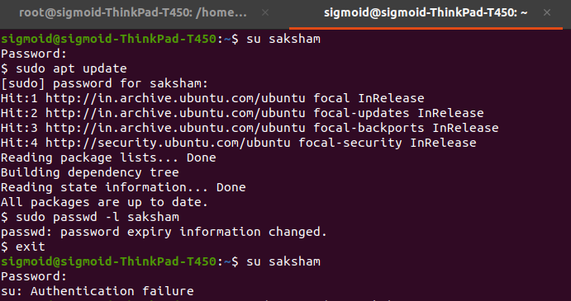
Sol::
add user with root access:
>sudo visudo

i added saksham as a root user & saved the file.

Now swtched to my profile saksham:
>su saksham
Password: saksham
>sudo apt update(to check if I can use sudo command and yes i can)

Now i want to restrict the user to use sudo commands, so i’ll simply lock the user by:
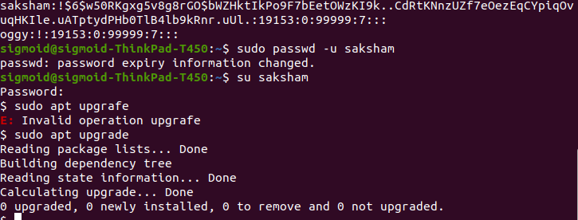
>sudo passwd -l saksham
(locking adds ! In fornt of the original password)

to check password use:
>sudo cat /etc/shadow (you can see the ! Added in front of saksham’s password)

to unlock simply:
>sudo passwd -u saksham

Q3. Configure your system in such a way that when a user type and executes a describe command from anywhere of the system it must list all the files and folders of the user's current directory.
Sol::

create a bash script for the command.
Opening bash file in nano editor in root user

>nano ~/.bashrc

bsahrc = run bash file

Now, to make the command to run, scroll to the bottom for the bash nano file and add this:

>alias describe='echo List of all items; ls'

echo prints the data and command is executed afterwords
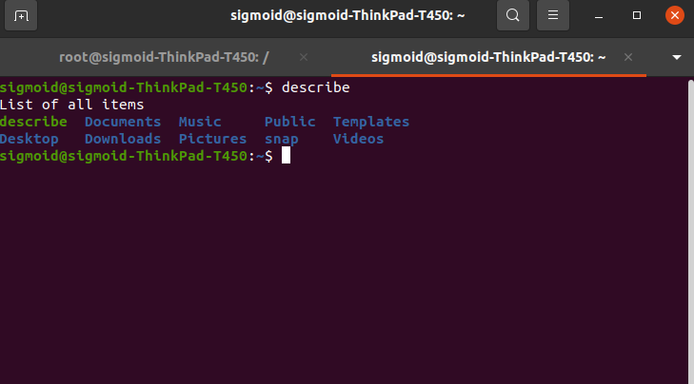
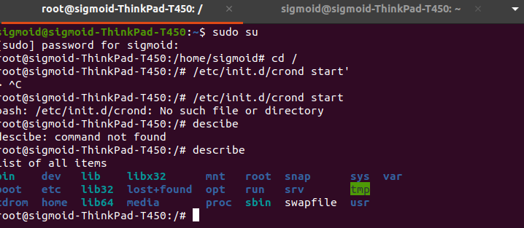

Q4. Users can put a compressed file at any path of the linux file system. The name of the file will be research and the extension will be of compression type, example for gzip type extension will be .gz.You have to find the file and check the compression type and uncompress it.

Sol::

Create a txt file named research anywhere(in my case it was desktop)
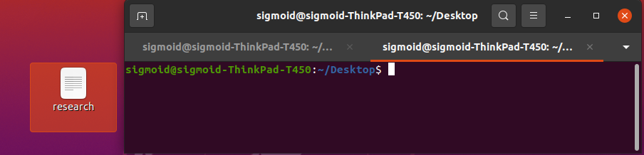
>cd Desktop

now compress the file in gzip:
> gzip research

to view the content of the file:
zcat research
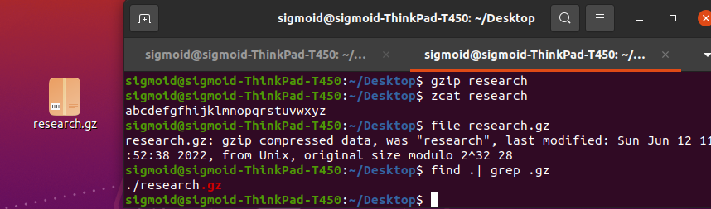
now, to check the compression type:
> file research.gz

now, to find gz file:
> find .| grep .gz

now to uncompress the file:
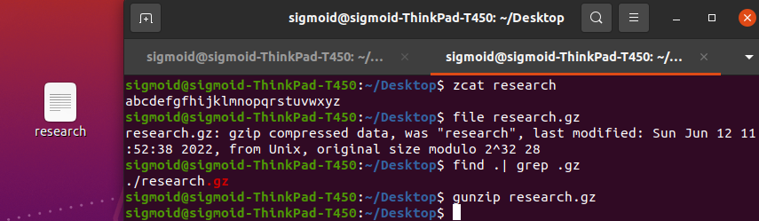
>gunzip research.gz

Q5. Configure your system in such a way that any user of your system creates a file then there should not be permission to do any activity in that file.
Note:- Don’t use the chmod command.
Sol::
To revoke pernmission to do any activity means any other user can not write and execute the file.
So we will set the umask value to 077 so that no other user can read and write the data.
Refer the screenshot below, you can see after changing umask value, only user has permission to read and write
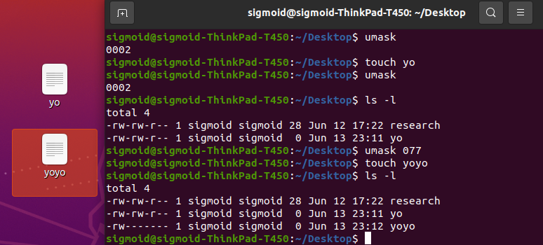

Q6. Create a service with the name showtime , after starting the service, every minute it should print the current time in a file in the user home directory.

Ex:-
sudo service showtime start -> It should start writing in file.
sudo service showtime stop -> It should stop writing in file.
sudo service showtime status -> It should show status.
Sol::
Create a file & write following code
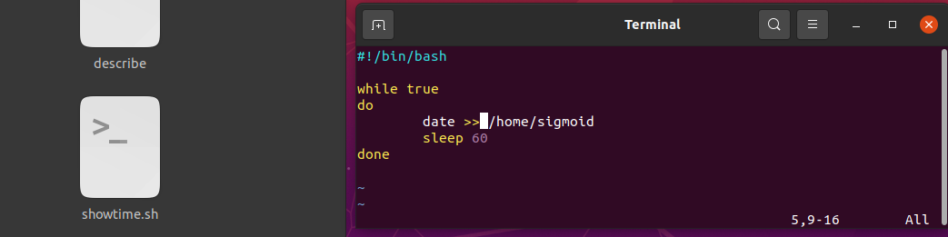
>vi showtime.sh

#!/bin/bash

while true
do
date >> /home/sigmoid
sleep 60
done

:wq!

Now, grant permission to file to execute:

>chmod a+x showtime.sh

Create a service file & write the following:
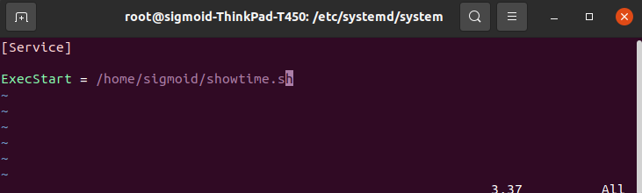
>cd /etc/systemd/system/
>vi showtime.service

[Service]

ExecStart = /home/sigmoid/showtime.sh

:wq!

Give permission to execute to this file :

>chmod +x /etc/systemd/system/showtime.service

Now you can use :

sudo service showtime start -> To start
sudo service showtime stop -> To stop.
sudo service showtime status -> To show status

